Multiple pigmentation in Laugier-Hunziker-Baran syndrome
Jun-ichiro Yamamoto¹, Atsushi Kasamatsu^{1*}, Morihiro Higo¹, Yosuke Endo-Sakamoto¹, Katsunori Ogawara¹, Masashi Shiiba², Katsuhiro Uzawa^{1,2}, and Hideki Tanzawa^{1,2}

¹Department of Dentistry and Oral-Maxillofacial Surgery, Chiba University Hospital, Chiba, Japan
²Department of Clinical Oncology, Graduate School of Medicine, Chiba University, Japan
³Department of Oral Science, Graduate School of Medicine, Chiba University, Chiba, Japan

*Address correspondence to: Atsushi Kasamatsu, Department of Dentistry and Oral-Maxillofacial Surgery, Chiba University, 1-8-1 Inohana, Chuo-ku, 260-8670, Chiba, Japan
E-mail: kasamatsua@faculty.chiba-u.jp; telephone: +81-43-226-2300; fax: +81-43-226-2151

Abstract. Laugier-Hunziker-Baran (LHB) syndrome is an acquired, macular hyperpigmentation of the lips and, oral mucosa, often associated with pigmentation of the nails, palms, and fingertips. LHB syndrome is considered to be a benign disease with no systemic manifestation or malignant potential. Normally, no treatment is required for this condition, unless for aesthetic reason, mainly due to pigmentation on the lip mucosa. Here we present a case of LHB syndrome, 32-year-old male, whose pigmentations on his tongue, buccal mucosa, palate, and ventral surface of fingertip, diagnosed by clinical and dermoscopic findings.

Key words: LHB syndrome, oral pigmentation, pigmentation of ventral surface of fingertip

Introduction
Laugier-Hunziker-Baran (LHB) syndrome is a rare, acquired, benign disorder of hyperpigmentation often involving the nails and melanotic pigmentation of the parts of the oral cavity, such as lips, tongue, buccal mucosa, and palate, and is frequently associated with longitudinal melanonychia [1-3]. Oral pigmentation is either focal or diffuse. The lesions present as multiple, flat, smooth, and pigmented macules of variable size and color, ranging from grey to brown or blue-black [4].
LHB syndrome is considered as a macular hyperpigmentation disorder with unknown etiopathogenesis, and is believed to have no correlated to somatic abnormalities. The pigmentary lesions carry no risk of malignant transformation. A few cases have been reported in related family members. Others have suggested that no genetic factors are associated with LHB syndrome [5-8].
Dermoscopy is a useful non-invasive technique for more accurate diagnosis of various cutaneous pigmented lesions [9]. We report here a case of LHB syndrome diagnosed by clinical and dermoscopic findings.

Case Report
A 32-year-old Japanese man was referred to the Department of Dentistry and Oral-Maxillofacial Surgery, Chiba University Hospital, for evaluation of pigmented areas in his mouth. The patient had noticed the pigmentation in his oral cavity 4 years ago and no major changes were observed prior the visit. Oral examination revealed multiple and painless brown pigmentation on the tongue, buccal mucosa, and palate (Fig. 1A). He was systemically healthy and was not on any medication. He was neither a smoker nor a drinker of alcohol. There was no family history of abnormal mucocutaneous pigmentation. We also found a melanotic macule on the ventral surface of fourth fingertip (Fig. 1B). Laboratory investigation results, including a full blood count, hematinic levels, serum chemistry, and inflammatory markers, were all within normal range. The patient underwent an upper gastrointestinal endoscopy, as well as a colonoscopy, which revealed no evidence of polyps. Inflammatory changes or malignant features were not noted in any area.
Dermoscopic examination of tongue and ventral surface of fourth fingertip revealed brownish, symmetry, and homogeneous pigmentation (Fig. 2A, 2B).
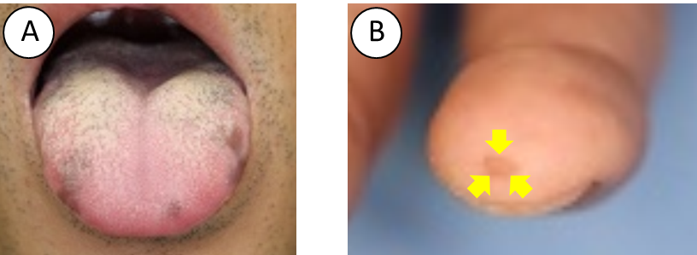
Fig. 1. Clinical appearance of the pigmented lesions:
(A), tongue; (B), ventral surface of fourth fingertip

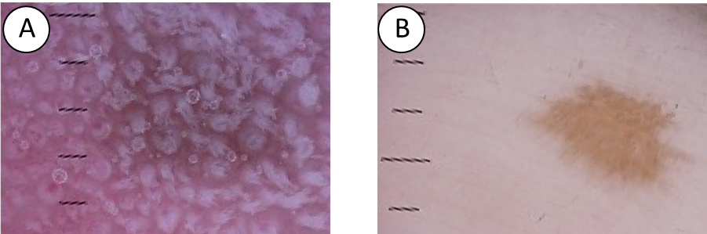
Fig. 2. Dermoscopic features of the pigmented lesions:
(A), tongue; (B), ventral surface of fourth fingertip.

A diagnosis of LHB syndrome was made based on the clinical and dermoscopic findings with the absence of systemic involvement.

Discussion
Diagnosis of LHB syndrome must be established to exclude underlying systemic pathologic conditions, such as Addison’s disease, Albright’s syndrome, and Peutz-Jeghers syndrome [10]. Addison’s disease is characterized by hyperpigmentation of the skin and mucosal membranes, associated with increased level of circulating adrenocorticotropic hormone (ACTH) [11]. Albright’s syndrome exhibits labial and genital pigmentation, but it is often unilateral and does not involve the nails. This disease is also accompanied by precocious puberty in females and fibrous dysplasia. Peutz-Jeughers Syndrome is characterized by intestinal polyposis and melanotic macules particularly of the face and mouth [12]. Diffuse oral pigmentation is also associated with systemic intake of drugs [13]. Especially, the causative drugs of pigmentation are tetracyclines, antimalarials, amiodarone, chemotherapeutic agents, oral contraceptives, phenothiazines, azidothymidine, and ketoconazole [13]. If drug-induced oral pigmentations are diagnosed correctly, the pigmentation will be resolved by suspension of those drugs. Negative evidence of systemic symptoms (such as fatigue, weight loss, cardiovascular, or gastrointestinal disorders, and normal plasma levels of cortisol and ACTH), negative drug history, and negative findings in upper gastrointestinal endoscopy and colonoscopy will aid in the diagnosis of LHB syndrome. Therefore, detailed history taking and through clinical examination of a patient presenting with oral pigmentation is of paramount importance [14].
Dermoscopic examination is an extremely useful tool in the diagnosis of palmoplantar pigmented lesions. The dermoscopic patterns associated with benign lesions are the parallel furrow, lattice-like, fibrillar, homogeneous globular, and acral reticular patterns [15]. Dermoscopy is a non-invasive technique that has been used to make more accurate diagnoses of pigmented skin and oral lesions [16].
Since LHB syndrome has not shown malignant transformation and systemic complications [5], no treatment was required for the patients with LHB syndrome, except patients with cosmetic complications or malignant suspicion [11, 17]. The importance of recognizing LHB syndrome is to avoid unnecessary examinations and treatments. Thus, LHB syndrome should be included in the differential diagnosis of oral pigmentation. Furthermore, accumulation of different findings of pigmented lesions in LHB syndrome could contribute to a more accurate diagnosis in the future.

Competing interests
The authors declare that they have no competing interests.

Acknowledgement
We thank Lynda C. Charters for editing the manuscript.

References
- Laugier P, Hunziker N. Pigmentation melanique lenticulaire, essentielle, de la muqueuse jugale et des levres [Essential lenticular melanic pigmentation of the lip and cheek mucosa]. Arch Belg Dermatol Syphilol 1970;26:391–9.
- Baran R. Longitudinal melanotic streaks as a clue to Laugier-Hunziker syndrome. Arch Dermatol 1979;115: 1448–9.
- Kanwar AJ, Kaur S, Kaur C, et al. “Laugier- Hunziker syndrome,” Journal of Dermatology 2001; 28:54–7.
- Zuo Y, Ma D, Jin H, et al. “Treatment of Laugier-Hunziker syndrome with the Q-switched alexan- drite laser in 22 Chinese patients,” Archives of Dermatological Research 2010; 302: 125–30.
- Pereira PM, Rodrigues CA, Lima LL, et al. Do you know this syndrome? An Bras Dermatol 2010;85:751–3.
- Moore RT, Chae KA, Rhodes AR, et al. A lentiginous proliferation of melanocytes. J Am Acad Dermatol 2004;50:S70–4.
- Ayoub N, Barete S, Bouaziz JD, et al . Additional conjunctival and penile pigmentation in Laugier- Hunziker syndrome: A report of two cases. Int J Dermatol 2004;43:571–4.
- Sabesan T, Ramchandani PL, Peters WJ. Laugier-Hunziker syndrome: A rare cause of mucocutaneous pigmentation. Br J Oral Maxillofac Surg 2006;44:320–1.
- Tamiya H, Kamo R, Sowa J, et al . Dermoscopic features of pigmentation in Laugier-Hunziker-Baran syndrome. Dermatol Surg 2010;36:152-4.
- Montebugnoli L, Grelli I, Cervellati F, et al. “Laugier-Hunziker Syndrome: an uncommon cause of oral pigmentation and a review of the literature,” International Journal of Dentistry 2010;525404.
- Ramakant S , Vijayalakshmi S , Jagadish V. Laugier–Hunziker syndrome. J Oral Maxillofac Pathol 2012;16: 245–50.
- Campos-Munoz L, Pedraz-Munoz J, Conde-Taboada A, et al. Dermoscopy of Peutz-Jeghers syndrome. J Eur Acad Dermatol Venereol 2009; 23: 730–1.
- Ferreira M, Ferreira A, Soares A, et al. “Laugier-Hunziker syndrome: case report and treatment with the Q-switched Nd-Yag laser” Journal of the European Academy of Dermatology and Venereology 1999; 12: 171–3.
- Ko JH, Shih YC, Chiu CS, et al. Dermoscopic features in Laugier-Hunziker syndrome. J Dermatol 2011;38:87–90.
- Malvehy J, Puig S. Dermoscopic patterns of benign volar melanocytic lesions in patients with atypical mole syndrome. Arch Dermatol 2004; 140: 538–44.
- Wondratsch H, Feldmann R, Steiner A, et al. Laugier-Hunziker Syndrome in a Patient with Pancreatic Cancer. Case Rep Dermatol 2012;4:174–6.
- Ergun S, Saruhanoğlu A, Migliari DA, et al. Refractory Pigmentation Associated with Laugier-Hunziker Syndrome following Er:YAG Laser Treatment. Case Rep Dent 2013;561040.

